**Proof of Concept: Augmented Reality - Signal Strength Visualization for Wifi / LTE & 5G (Drone Survey/AR Viz)**

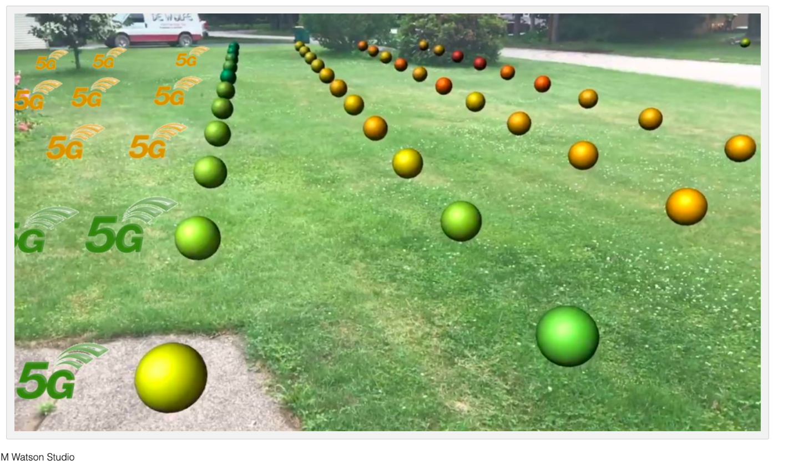

Project Skittles is exciting, because it demonstrates the value of:

MAKING VISIBILE THAT WHICH IS INVISIBLE - which extends beyond RF...

<https://youtu.be/IDFRuG_D3Io>

Drone Surveys WIFI Signal Strength and AR Visualize

JUne 21 2019 Test

<https://youtu.be/8RCgh8jv3xM>

<LINK> Magic Leap POC

<https://drive.google.com/file/d/1anMDbpGhPwmJgdW0g9LFMvxkqqKu8vUb/view>

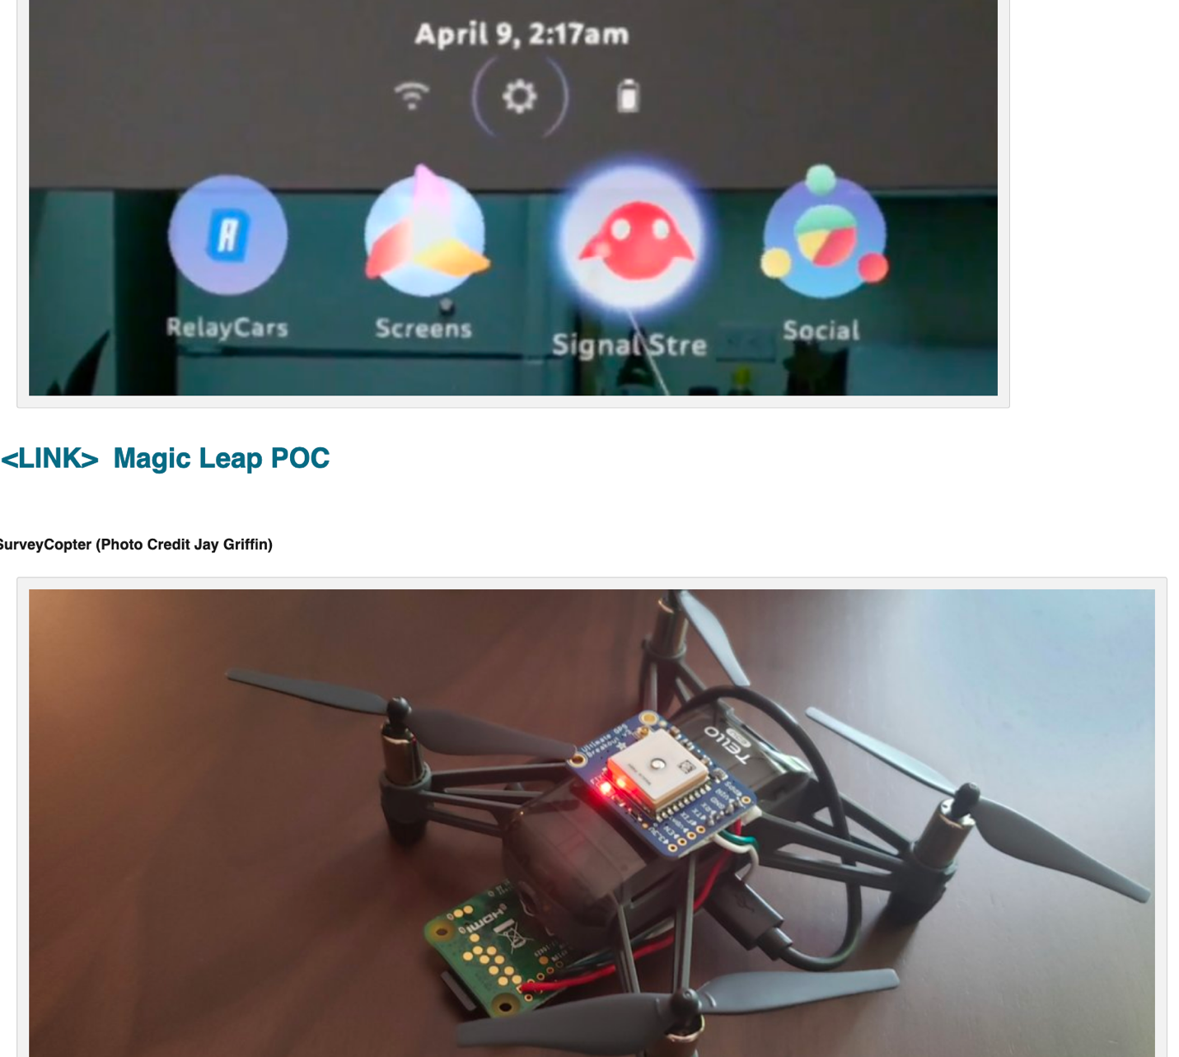

SurveyCopter (Photo Credit Jay Griffin)

Loaded Drone with Gear - Test Flight #1

<https://youtu.be/hOexOQfU9gw>

POC at IBM Watson West (LTE Data)

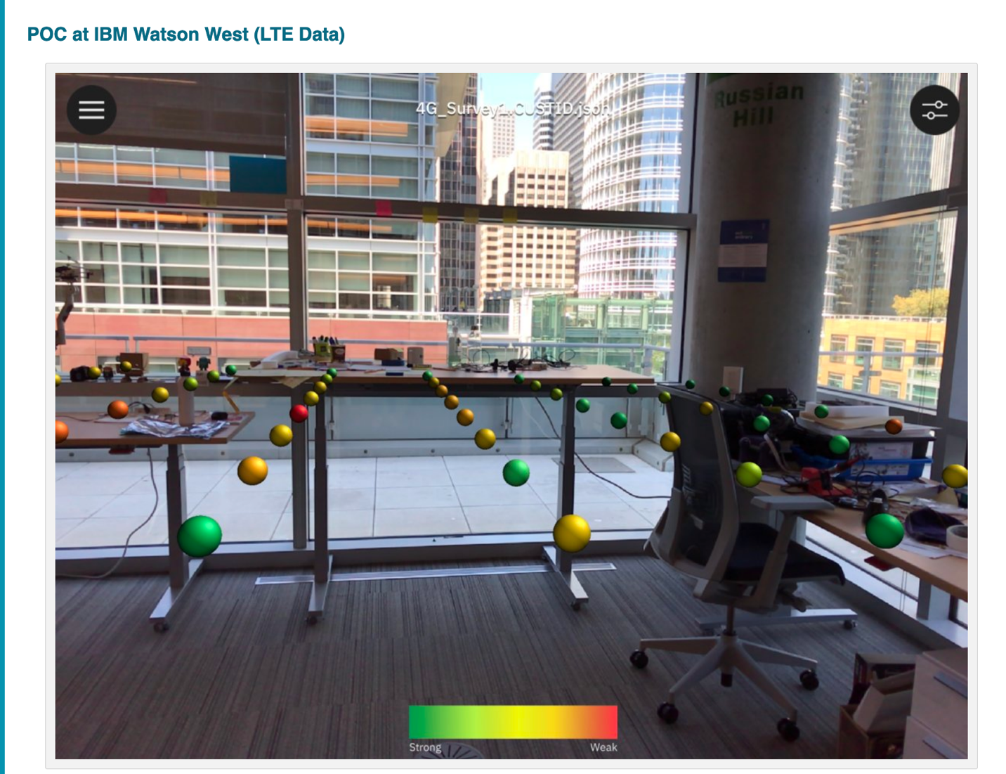

Demonstration / Value

Show that AR Tech can be applied to visualize and remedy weak points in evolving 5G networks (better antenna placements)

Especially valuable given the gnarly physics of 5G - e.g.

https://www.forbes.com/sites/annatobin/2018/05/25/could-5g-have-trouble-penetrating-buildings/#242c229f9f97

Visualization:

Point cloud , anchored to physical location

Data Sources (Real world)

WIFI Signal Strength Level

LTE Signal Strengh Level

Ping Test

X Y Z coordinates (For above)

Attenuation in Weather? (explore & visualize) - fog, rain and drizzle

source: https://www.sciencedirect.com/topics/engineering/atmospheric-attenuation

<https://youtu.be/rnQF_XWvmEs>

Mapping Options:

Manual (MAC)

Manual (Raspberry PI with a button - and some 1m resolution locator - GPS or other localized data)

Drone - fly drone 8 X 8 X 3 (think about three chess boards) - taking measurements

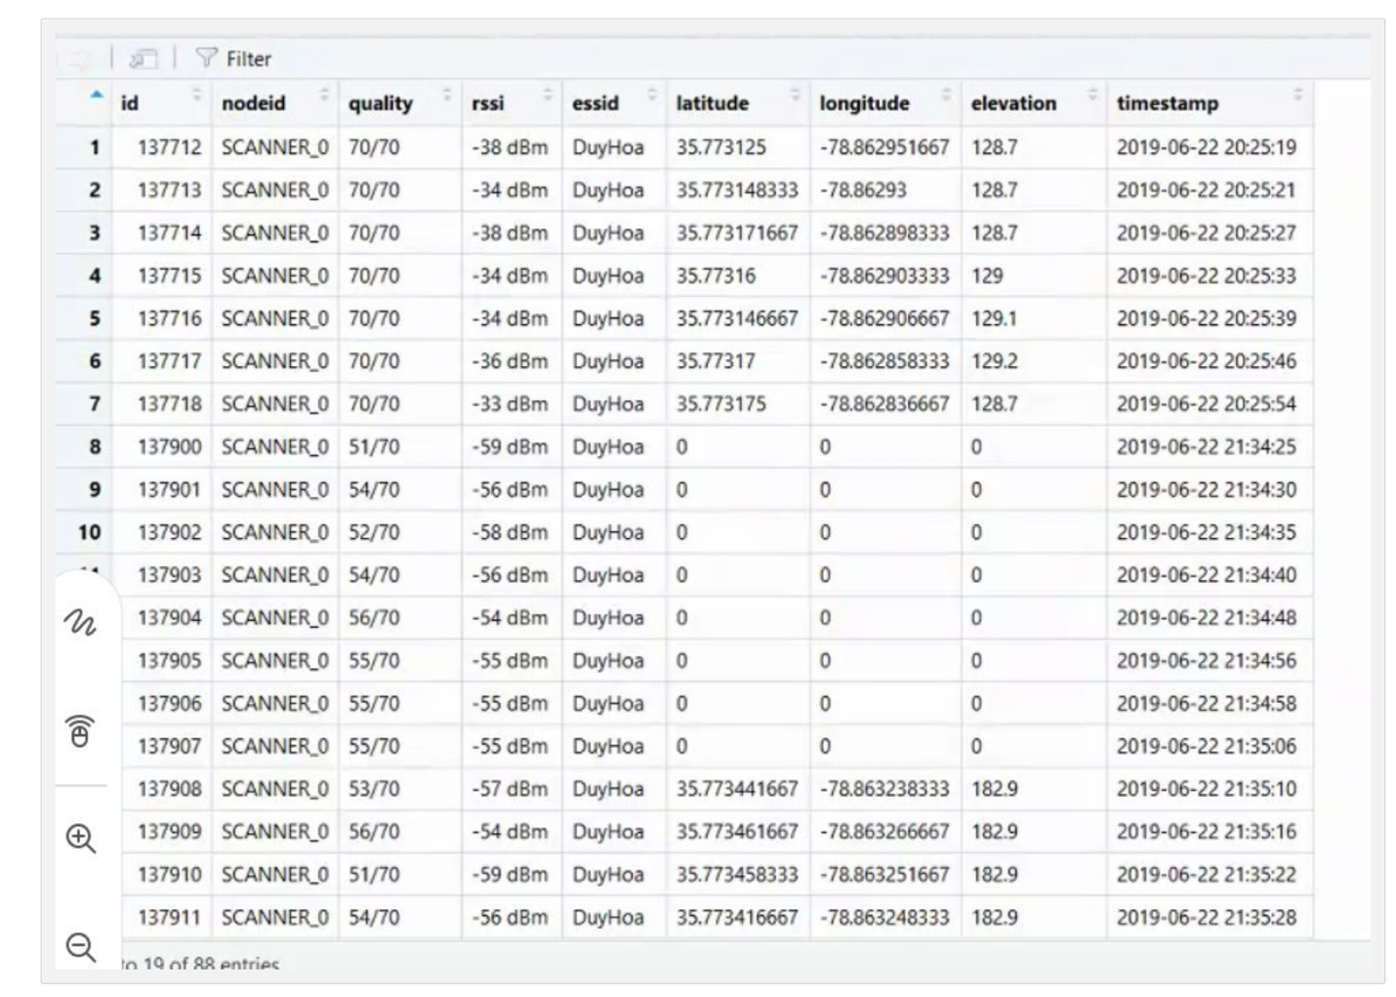

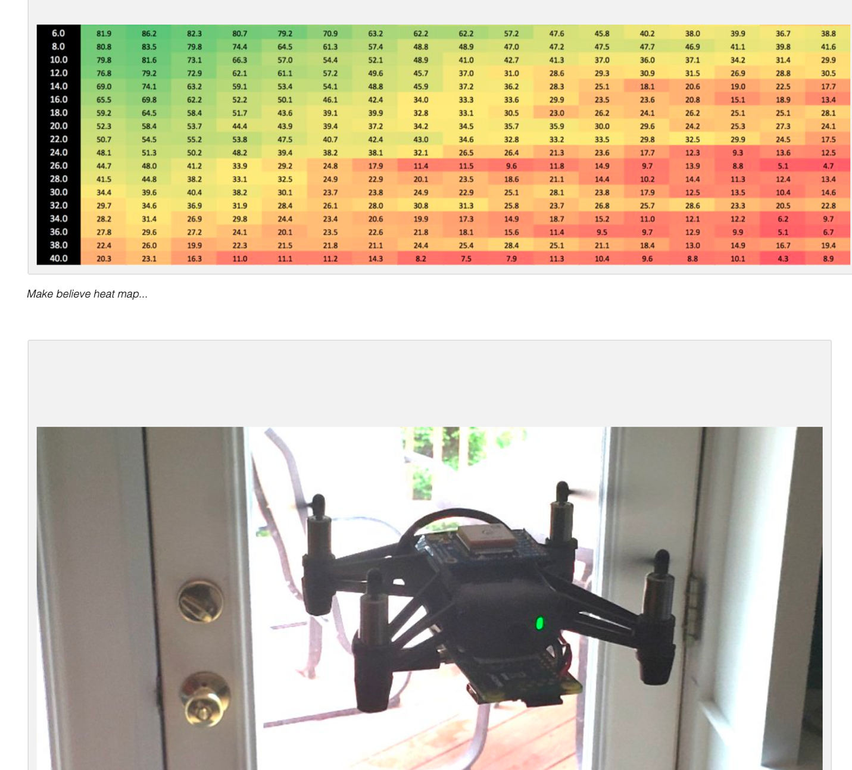

Actionable Insights:

Adjust mesh antennas (rotate, relocate, or add more) to ensure sufficient coverage across physical space.

Modify Policies to ensure choke points are prioritizing network or compute that is priority

Post It Credit :) - Jenna G.

Trade Show WIFI Visualized - June 2019

Started with Dummy Data... then

https://github.com/rustyoldrake/Catchers_Mitt/blob/master/Signal%20Strength%20Basic%20Data%20Generator.csv

https://github.com/rustyoldrake/Catchers_Mitt/blob/master/Signal%20Strength%20Basic%20Data%20Generator.xlsx

Make believe heat map...

... Real Data - Mapping Signal Strength for Real

mac terminal >

while x=1; do /System/Library/PrivateFrameworks/Apple80211.framework/Versions/Current/Resources/airport -I | grep CtlRSSI; sleep 0.5; done

wifi SSI - you can script, or just walk around your room and holler to your friend the coordinates and 'level'

Test Flight #2 (Jay Griffin) - Drone Programmed in Node Red to Survey and Get signal strength

BIll of Materials

1x Tello-EDU drone $99

https://store.dji.com/product/tello-edu?vid=47091

* Be sure it is the "EDU" version of the drone. It allows for easier wireless connectivity for accessing the flight SDK

recommended accessories:

spare propellers $4

https://store.dji.com/product/tello-propellers

spare battery $19

https://store.dji.com/product/tello-battery?from=compatibility

battery charging hub $25

https://store.dji.com/product/tello-battery-charging-hub

1x(3x) Raspberry PI Zero W $10

https://www.adafruit.com/product/3400

for $10 ea. spares are good

I got this kit for a bit more which covered most accessories $60

https://www.adafruit.com/product/3411

1x GPS breakout card $40

https://www.adafruit.com/product/746

Other items

wire spools (4 colors needed, 6 in the pack) $16

https://www.adafruit.com/product/1311

Solder $8

https://www.adafruit.com/product/145

iron $22

https://www.adafruit.com/product/180

solder wick (recommended if soldering novice, mandatory if expert.... or so I'm told) $3

https://www.adafruit.com/product/149

Really short usb cable: $6 (important for weight and mounting balance)

https://www.amazon.com/CableCreation-Compatible-Kindle-Android-Tablet/dp/B01M5GZ3N0/ref=sr_1_1_sspa?keywords=CC0573-2&qid=1559593854&s=electronics&sr=1-1-spons&psc=1

total ~$300 depending on replacement part insurance.

==

Prior Work (Pre-POC) - Proof of Concept (Magic Leap)

thanks Jake Madden!

Jake did a POC > he "created a test Magic Leap Unity project that reads in the csv file and creates colored spheres of sizes corresponding to the strength value and similar color scheme to the example table... captured a short video demonstrating on the ML1. It doesn't factor in walls for occlusion presently but could and demonstrates the idea."

Video Demo

The video is around 80mb:

https://drive.google.com/file/d/1anMDbpGhPwmJgdW0g9LFMvxkqqKu8vUb/view?usp=sharing

What Next 1?

Weather, Humidity, Pollutants, Altitude impact on propogation and models

https://www.etsi.org/images/files/ETSIWhitePapers/etsi_wp25_mwt_and_5g_FINAL.pdf

What Next 2?

<https://youtu.be/nRN4vUECzRU>

Mini-Project 1 - MANUAL MAP - Do some REAL WORLD signal strength mapping (hand hold a Mac, or phone) and manually create a (A) WIFI Strength ; (B) LTE / 4G Signal Strength

Mini-Project 2 - DRONE Survey - program a drone to SURVEY an area - 1 meter grid coordinates, measure, move , measure, move (could also be a ROOMBA)

Mini-Project 3- Explore 3D mesh of Room / Enviroment (thanks Joe P!) https://www.6d.ai/ APIs for Augmented Reality and the AR Cloud. With just a smartphone camera, 6D.ai's SDK creates a 3D mesh of the world around you. App developers can easily relocalize multiple cross-platform players into the same coordinate system. Objects remain persistent across sessions while respecting occlusion (JP > for "signal strength demo could be that you only see the spheres that are within your view")

Mini-Project 4 - GHOST Protocol - visualizing an after-image for security or perimiter monitoring

Mini-Project 5 - overlay multiple frequencies - e.g. 5G and LTE and WIFI on same viz (find juicy network in a stadium or event)

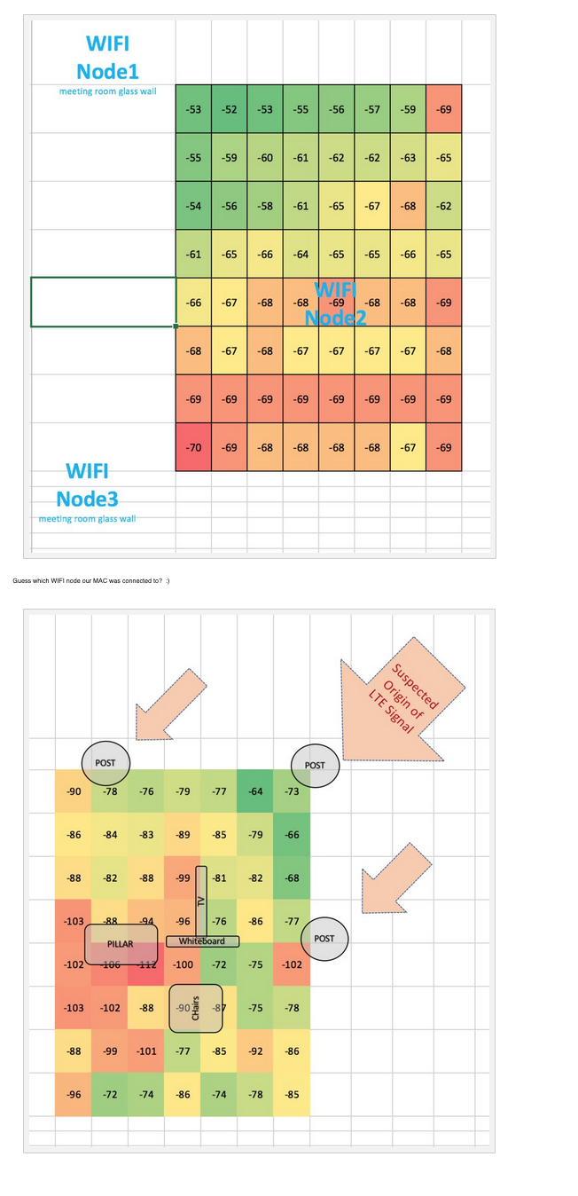

IBM Watson Studio

https://www.ibm.com/cloud/watson-studio

IBM Immersive Data:

https://www.youtube.com/watch?time_continue=111&v=6Nni5ywbEqo

For Later:

Dial and call "*3001#12345#*" to enter iOS Field Test mode.

https://medium.com/ibm-watson/visualize-high-dimensional-data-fast-watson-studio-ebad7e7e1b6a

Guess which WIFI node our MAC was connected to? :)

OTHER LINKS

Finding Hidden Cells Phones in Prisons

https://medium.com/@gwilymnewton/finding-hidden-cells-phones-in-prisons-16421352e039